Project Wealthy Minds
Higher National Diploma in Software
Engineering



School of Computing and Engineering
National Institute of Business Management Colombo-7

PROJECT MEMBERS:
U.G.D.S. Karunathilake (COHNDSE252F-026)
T.N.V. Perera (CODSE243F-065)
Ravindu K.A.D.C(COHNDSE252F-001)



Student Index Number: COHNDSE252F-001
NIBM Registered Name: K.A.D.C. Ravindu
Program: Higher National Diploma in Software Engineering
Batch: HNDSE 25.2F

TABLE OF CONTENTS
- Introduction
- Problem Statement
- Literature Review
- Proposed Solution
- System Functionalities
- Selected Data Structure and justification
- Novel Features
- Technologies Used
- Selling Points of the Application
- Individual Reflection
- Conclusion
- Reference
LIST OF FIGURES
Figure 1. Max-heap used to prioritise major expenses
LIST OF TABLES
Table 1. Existing tools and identified gap
Table 2. Input-process-output mapping
Table 3. Core operation complexity
- Introduction
Many students and young adults can see how much money they spend, but they don't always understand what their spending habits mean. Wealthy Minds is trying to make this information more simple. The system tracks income, expenses, savings, investments, loans, subscriptions and financial goals. It then uses these records to generate financial statements, a Financial Health Score, behaviour patterns, potential future expenses, and practical actions to take. Thus, the application does more than just record transactions, it helps the user understand the patterns, risks and next steps behind the numbers.

- Problem Statement
Most personal finance applications are useful for tracking money and creating budgets. However, the information is often spread across separate views for transactions, accounts, subscriptions and goals. This can make it difficult for a user to decide which financial issue needs attention first. Wealthy Minds aims to solve this by providing one clear decision-support layer that organises the data, explains how the financial records are connected and highlights urgent issues. Therefore, the selected data structure must have a practical purpose in the system and directly support the speed and logic of its main feature
- Literature Review
Existing finance applications already provide several useful features. YNAB allows users to set spending and savings targets and test loan repayment plans (YNAB, 2025, 2026). Rocket Money supports budgeting, spending analysis and subscription monitoring, although some advanced features require Premium (Rocket Money, 2026). Empower brings together cash-flow, budgeting and portfolio information at account level (Empower, 2026). Although these applications are strong at tracking and visualising money, Wealthy Minds takes a different approach by combining behavioural scoring, predictive warnings and clear data-structure-based prioritisation in one educational application.

Table 1. Existing tools and identified gap
Existing tool | Established capability | Gap addressed by Wealthy Minds
YNAB | Spending targets and loan planning | One behavioural score with clear predictions
Rocket Money | Budgeting and subscription tracking | Alert-priority logic that users can understand
Empower | Cash-flow and investment dashboards | Financial relationships explained through data structures

4. Proposed Solution
Wealthy Minds uses a max-heap for its prioritisation function so that the most important expense or alert remains at the root. Each item is given a priority score according to quantity, urgency, proximity to due date and likelihood of recurrence. The new item is placed at the bottom and then sifted up until the heap order is restored. The highest-priority item is removed, the last item is moved to the root and sift-down is used to restore the heap. This approach can also be used to find top-k expenses, detect unusually large payments, and bring urgent subscription or loan warnings to the user’s attention.

5. System Functionalities
• Allow users to record income, expenses, savings, investments, loans, subscriptions and financial goals.
• Prepare category-wise summaries of monthly, quarterly and yearly statements.
• Calculate a Financial Health Score and clearly describe the factors that contribute to it.
• Expect potential future costs, provide helpful alerts and recommend corrective actions.
Table 2. Input-process output mapping
Input | Processing | Output
Transaction, amount, category, date | Validate and store data, then apply the selected structure | Organised and searchable financial record
Accounts, loans and goals | Analyse behaviour and calculate the health score | Score, trend and a clear explanation
Historical spending | Forecast spending and check alert thresholds | Prediction, alert and suggested action

6. Selected Data Structure and Justification
A heap was selected because the system does not need to arrange every financial record in a completely sorted order. Instead, it mainly needs to quickly identify the record that requires attention first. With a heap, the highest-priority item can be accessed in O(1) time, while inserting or removing an item takes O(log n) time. A heap can also be created from n items in O(n) time, making it efficient for managing large amounts of financial data.
However, finding a particular item in a heap may take O(n) time. Therefore, this structure is best suited for prioritizing financial records rather than performing general transaction searches. Java’s PriorityQueue works similarly, as it uses a priority heap and allows items to be arranged using either their natural order or a custom comparator (Oracle, n.d.).
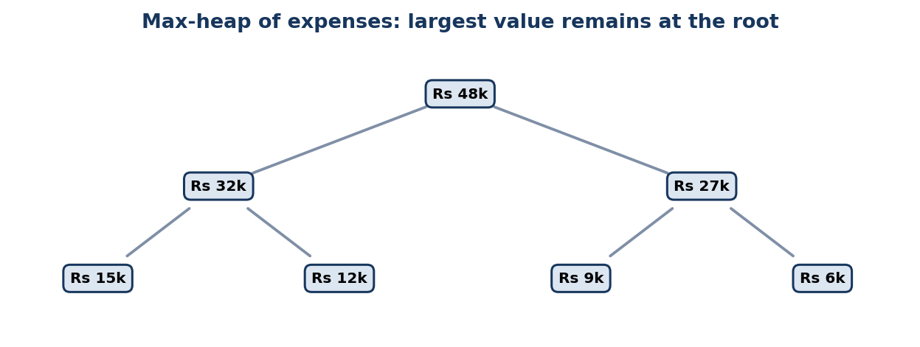

Figure 1. Max-heap used to prioritise major expenses
Table 3. Core operation complexity
Operation | Expected / typical | Worst case
Peek highest priority | O(1) | O(1)
Insert item | O(log n) | O(log n)
Remove maximum | O(log n) | O(log n)
Build heap | O(n) | O(n)

7. Novel Features
Top-k Expense Radar, which shows the transactions that may have the greatest immediate effect on the user's finances.
Adaptive Alert Priority, which considers the amount, due-date proximity and behaviour risk of each alert.
What-if Budget Rescue, which updates the alert priorities after the user tries a possible spending reduction.
8. Technologies Used
I plan to develop the prototype in Java using ExpenseItem, FinancialAlert and MaxHeap classes together with a comparator-based priority score. A JavaFX or Swing interface can display the alerts in ranked order. JSON or CSV files can store the test data, while JUnit can check that the heap property remains correct after every insertion and removal. Java's PriorityQueue can be used for comparison, but building a custom array-based heap makes the parent and child indices, as well as the sift operations, easier to explain during the viva.

9. Selling Point of the Application
Helps users take action instead of only storing transactions.
Gives clear reasons for every alert and Financial Health Score.
Designed as a free and educational tool for students and young adults.
Uses a modular design to demonstrate a practical data-structure use case
10. Individual Reflection
Learning Journey
Working on Wealthy Minds is helping me understand how heaps can be used in a real system. I am responsible for designing the financial priority formula and developing the array-based max-heap, including insert, peek, extract-max, sift-up, and sift-down. During this process, I have learned that the largest expense is not always the most urgent, so several factors need to be considered when assigning priority.
Key Takeaways
- Heap Operations: I am improving my understanding of max-heap operations.
- Priority Rules: I have learned how to compare expenses using both amount and urgency.
- Testing: I now understand the importance of testing equal priorities, repeated removals, and empty queues.
Development Process
I started by defining the priority formula and comparison rules. I am now implementing the heap operations step by step and testing them with different financial records. This approach is making the code easier to understand and debug.
Challenges & How I Am Solving Them
- Amount vs. Urgency: I am creating a comparator that considers several priority factors.
- Maintaining the Heap: I am using sift-up and sift-down to maintain the heap after insertions and removals.
- Search Limitation: Since searching takes O(n), I am keeping the heap focused on ranking expenses and scheduling alerts.
Repository Links
- GitHub Profile: chethana0307
- GitHub Repository: Wealthy Minds

11. Conclusion
Overall, the heap module shows how choosing the right data structure can improve a real feature in a financial application. It gives Wealthy Minds an efficient and understandable way to turn raw records into ranked expenses and alerts. The module is also simple enough to implement, test and explain during the viva. At the same time, its limitation for arbitrary searching is clearly recognised, which keeps the performance claims realistic and leaves room for future improvement. When combined with the prediction, scoring and recommendation features, the heap helps Wealthy Minds move beyond basic expense tracking and provide practical financial guidance
Implementation Validation Plan
Test the heap with normal, empty, duplicate and boundary inputs.
Compare each heap operation with a small dataset calculated by hand.
Measure execution time as the dataset grows and compare the results with the expected complexity.
Ask users to complete tasks involving data entry, finding insights and recovering from errors.
Reference
- Empower. (2026). Budget and cash flow planner. https://www.empower.com/tools/budgeting-cash-flow
- Hamilton, K. (2025, November 11). What is Rocket Money and why should you sign up? Rocket Money. https://www.rocketmoney.com/learn/personal-finance/what-is-rocket-money
- Oracle. (n.d.). PriorityQueue (Java Platform SE 8). https://docs.oracle.com/javase/8/docs/api/java/util/PriorityQueue.html
- Wong, R. (2025, May 19). Slay your loans with YNAB’s loan payoff simulator. YNAB. https://www.ynab.com/blog/ynab-loan-planner
- YNAB. (n.d.). Features. Retrieved August 2, 2026, from https://www.ynab.com/features

